**Brandon Hobbs**

**CS-340**

**September 27, 2022**

**Module 5: Client-side Authentication**

* **Add a unique Dashboard Identifier**  
  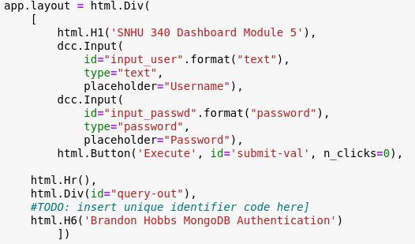  
  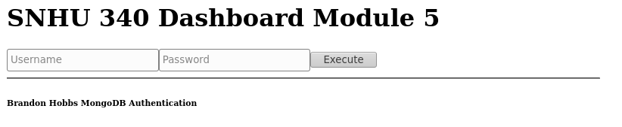
* **Import the CRUD module**  
  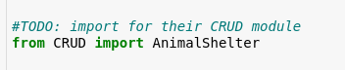  
  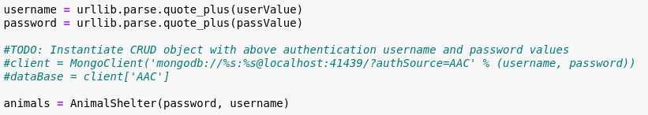
* **Callback Routine Functionality**  
    
  
* **Test Dashboard**  
    
  